# SOLAR FINANCING GUIDELINE – COMMERCIAL, INDUSTRIAL AND RESIDENTIAL

*With ever increase energy generation costs and failing old steam and hydro generators, Solar have become a better alternative for power generation, looking at both environmental impact and costs of running the solar farm or plant. A properly designed Solar system have a Return On Investment, it pays back. The ONLY issue on going solar is the Initial capital expenditure, As In4solar solution have partnered with financial institutions to cater for these financial constraints to make your dream possible.*

# Option 1 Power Purchase Agreement

* *You ONLY pay for what you use*
* *You SAVE MONEY from day one*
* *No hidden cost. No secret,*

**Advantages of PPA**

|  |  |  |  |
| --- | --- | --- | --- |
| ***A huge saving*** | ***Limited Risk*** | ***Potential*** | ***Monitoring*** |
| ***from day one*** |  | ***increase in property value*** |  |
| *•Saving is done from day one since its deposit free and no installation costs* | *•In4solar solutions and partners will be responsible for system performance and operational risk* | *•A solar PV system increases property values.* | *•In4solasolution monitors solar system we monitor them to ensure customers get optimum*  *harvest all the time* |

# Introducing Cheaper energy solutions for commercial and Industrial establishment

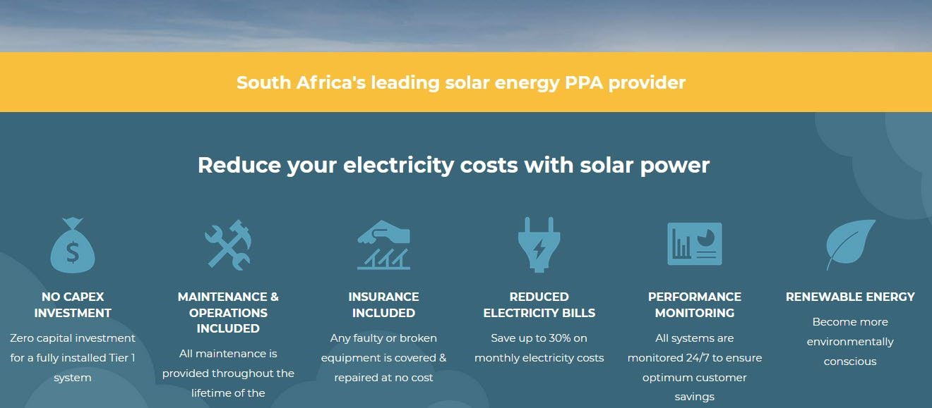

VAT no 419 028 8201 Email: info@in4solarsolution.co.za

# No Capex

*Zero capital expenditure. save from day one.*

*In4solar solutions and Partners will supply all material as designed and install*

# Maintenance and operations

*Maintenance of the system is done as per request from the client*

***Reduced electricity bill***

*Save up-to 30% of your electricity bill*

***Performance and Monitoring***

*Real time monitoring*

***Smart Metering***

*Consumer Usage, and transparency – Consumers at each individual unit will be given near real-time access to their usage data, which will prevent errors and billing queries and encourage better electricity usage behaviour over time. An accurate bill Is therefore sent out at the end of each month.*

***Billing***

*We will use our system to the smart metering to generate power consumption data which is also available to the client to see and verify.*

* *Energy costs are Predictable. Client is protected from unpredictable electricity tariffs*
* *You only pay for what you use, If the Solar system doesn’t produce energy, you don’t have to pay*
* *In4solar uses high-quality solar equipment and experienced project leadership and team*.

## GRID TIE SYSTEM BEST FOR COMMERCIAL AND INDUSTRIAL

***Grid tied systems*** *consist of only 2 key components –* ***solar*** *panels and a dedicated* ***grid tied*** *inverter. All the electric power generated by the* ***solar*** *panels feeds through a main synchronized inverter directly into your distribution board and offsets the power you would normally consume from the utility*.

*This is the system we encourage for C&I customers mainly. This is so because your working hours are also our solar peak production hours 0800hrs to 1600hrs, you knock off when the solar production plummets on the bell like graph, During the day you are practically off the grid when the sun goes down the system will switch to the utility of which this period your usage have dropped quite significantly. For establishments without NIGHT SHIFT, your utility bill will drop by up-to 70%*

# Benefits of Grid-Connected Solar Systems

* *Very affordable*
* *Reduces your bill up-to 70%*
* *Increases the value of your property*
* *Low capex cost because battery storage*
* *Exceptionally reliable*
* *Reduces your generator running costs*
* *Warranty extension up to 25 years for grid tied invertors*
* *Panels already come with a 25-year warranty*

# Disadvantages of Grid-Connected Solar systems

* *Dependent on the Grid availability*
* *No Grid no production*

***Solution***

*To short coming grid tied invertors*

***Introducing generator PV coupling***

***When there is load shedding the generator automatically starts thereby switching the grid tied invertors then the production resumes***

# Generator coupled to PV solar, fuel consumption comparison

*The table below outlines an approximation of the diesel generator fuel consumption per hour in litres. We have shown the usage at various load levels across a range of generators from 10kVA to 500kVA.Take note this table should only be used as an approximate to give you an indication of fuel usage at various load levels. Actual usage may vary slightly due to various factors.*

|  |  |  |  |  |
| --- | --- | --- | --- | --- |
| **Generator Size** | **In4solar Solution Approximate Diesel Fuel Consumption** | | | |
| **¼ Load**  **(litres/hr)** | **½ Load**  **(litres/hr)** | **¾ Load**  **(litres/hr)** | **Full Load**  **(litres/hr)** |
| 8kW / 10kVA | **0.9** | **1.2** | **1.7** | **2.1** |
| 10kW / 12kVA | **1.0** | **1.4** | **2.1** | **2.6** |
| 12kW / 15kVA | **1.3** | **1.8** | **2.6** | **3.2** |
| 16kW / 20kVA | **1.7** | **2.4** | **3.5** | **4.3** |
| 20kW / 25kVA | **2.1** | **3.0** | **4.3** | **5.4** |
| 24kW / 30kVA | **2.6** | **3.6** | **5.2** | **6.4** |
| 32kW / 40kVA | **3.4** | **4.8** | **7.0** | **8.6** |
| 40kW / 50kVA | **4.3** | **6.0** | **8.6** | **10.7** |
| 60kW / 75kVA | **6.4** | **9.0** | **12.7** | **16.1** |

|  |  |  |  |  |  |  |
| --- | --- | --- | --- | --- | --- | --- |
| 80kW / 100kVA | |  | **8.3** | **11.9** | **16.1** | **21.4** |
| 120kW / 150kVA | |  | **10.9** | **17.3** | **24.1** | **32.1** |
| 160kW / 200kVA | |  | **14.1** | **22.9** | **32.7** | **42.8** |
|  | 200kW / 250kVA |  | **17.4** | **28.6** | **40.8** | **53.5** |
| 280kW / 350kVA | |  | **23.7** | **39.3** | **56.0** | **74.9** |
| 400kW / 500kVA | |  | **33.3** | **55.6** | **79.6** | **107.0** |

|  |  |  |  |  |  |
| --- | --- | --- | --- | --- | --- |
| ***Generator***  ***size*** | ***Load Shedding at 4 hours a day*** | ***Running without Solar @ 100% fuel consumption*** | ***Costs of running without solar @ 1.30 per***  ***litre*** | ***Running with Solar will be @***  ***25%*** | ***Costs of running with solar @ 1.30***  ***per litre*** |
| *200kw /*  *250kva* | *4 hours* | *214 litres* | *278.2 usd* | *69.6 litres* | *90.48usd* |
|  | *1 week* | *1 498 litres* | *1947.4 usd* | *121.8 litres* | *162.24usd* |
|  | *Month* | *5 992 litres* | *7789.6 usd* | *487.2 litres* | *633.36usd* |
|  | *Year* | *71 904 litres* | *93 475.2 usd* | *5846.4*  *litres* | *7 600.32usd* |
|  |  |  |  |  |  |

*Going solar will save you A LOT OF MONEY as the table above shows running with solar will save you*

*85 874.88usd per year*

*Below is a graph showing a 20-year saving*

### NB

1. *The contract period varies from 3-14years, bigger corporate companies might go up to 20 years because of value*
2. *The rates for PPA varies with factors like EPC costs, Solar yield and how many days a company operate per week*
3. *The client owns the system from day one, therefore giving room to claim the S12B tax benefit.*
4. *Client needs to insure the system*

***Option 2 - Asset Finance FOR RESIDENTIAL***

***How does asset financing work?***

* ***ASSET FINANCE*** *- enables you to purchase an asset by spreading the cost over a set period, at the end of that set period, the asset is yours to keep forever.*
* *Online monitoring and maintenance will be done by In4solar solution*

### RESIDENTIAL SOLAR INSTALLATION

* *convenience no-more load shedding,*
* *Utility bill reduction*

## Option 3 - Outright Cash payment

* *The system belongs to you from day one, you break even on the Return of Investment is 6 years and then its SAVINGS throughout*
* *You own the system from day one*

***Hints- Solar is an expensive investment,***

### Do it right the FIRST TIME,

* *do you research,*
* *Lithium-ion battery – go with a good battery, 10 years is standard warranty on the market,*
* *Inverter, go with a good reliable brand that gives you complete control and flexibility of your solar system,*
* *Check* ***TECHNICAL SUPPORT*** *of inverter of choice,*
* *Check data, specifications of all your major equipment, the data should be readily available on the* ***ONLINE****, see reviews of the equipment’s from* ***SOLAR PANELS, INVERTER*** *to* ***BATTERY*** *and even the* ***INSTALLER*** *check their credibility as well*
* *Check battery to inverter compatibility all this information is readily available on the* ***INTERNET***

*Point to* ***WATCH****, don’t just do it because it’s* ***CHEAP…….!, YOU WILL SURELY PAY FOR IT******LATER****,*

### THERE IS NO SUBSTITUTE FOR QUALITY AND VALUE

***BUY EQUIPMENT THAT ADDS VALUE****!*